# PREPARATION

1. Backend : Laravel 7.*
   * + 1. Use Passport to Authentication API
2. Frontend : Vue.js
   * + 1. Use library Swal to show pop-up notification
       2. Use library axios to get & send data with API
       3. Use library vue router to create a route more easily
       4. Use library Bootstrap, jQuery dan Popper.js
3. Database : MySQL

# config

1. Backend (Laravel)
   1. Go to root folder and find .env file. You can change the
      1. DB_DATABASE, DB_USERNAME, DB_PASSWORD to setting database that used

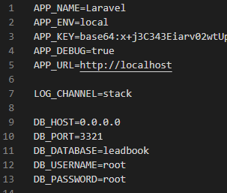

* + 1. MAIL_USERNAME, MAI_PASSWORD & MAIL_FROM_ADDRESS ​​to set the sender email link verification and reset password

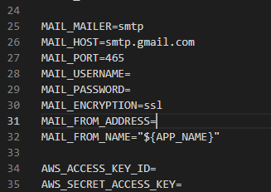

1. Frontend (Vue.js)
   1. Go to root folder and find .env file. Change the VUE_APP_URL to API URL you use

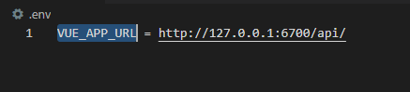

# SYSTEM

## Design System

System have Authentication & Company feature

1. Authentication Feature

In this feature there are 5 features, namely:

* 1. Login (http://127.0.0.1:8080/login)

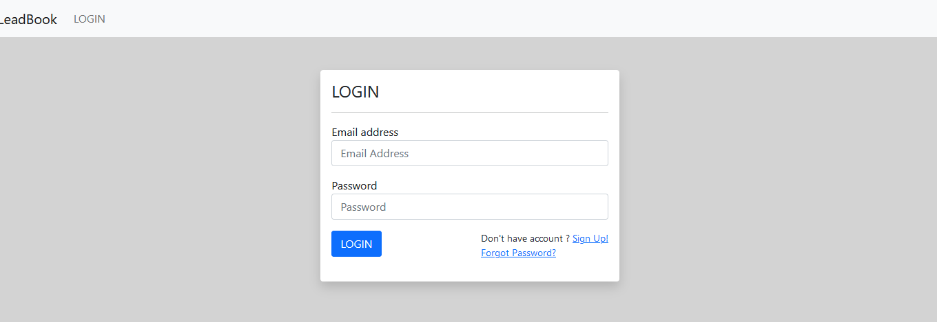

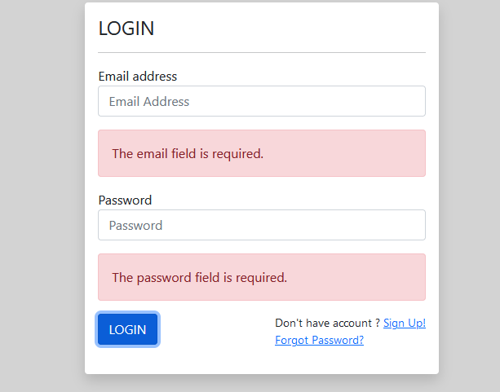

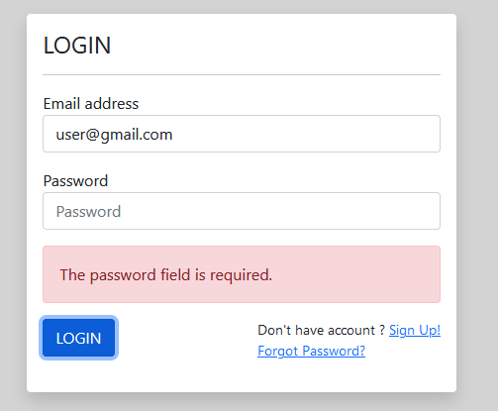

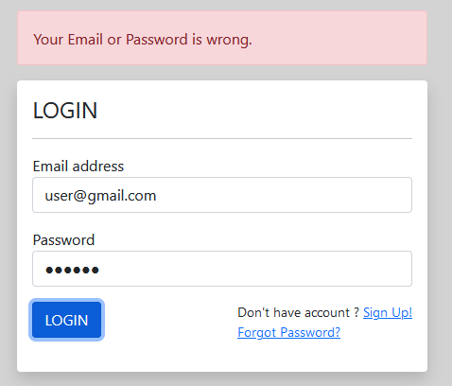

* 1. Logout

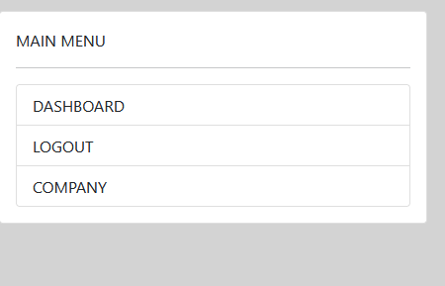

* 1. Register

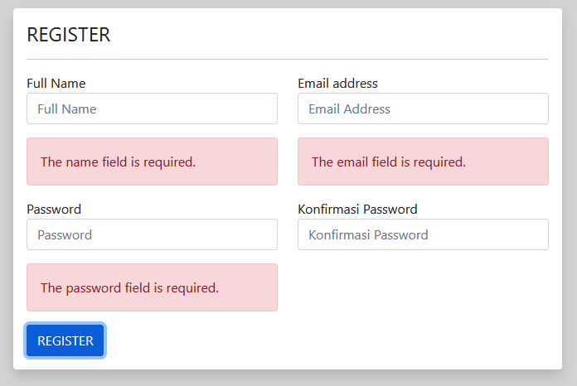

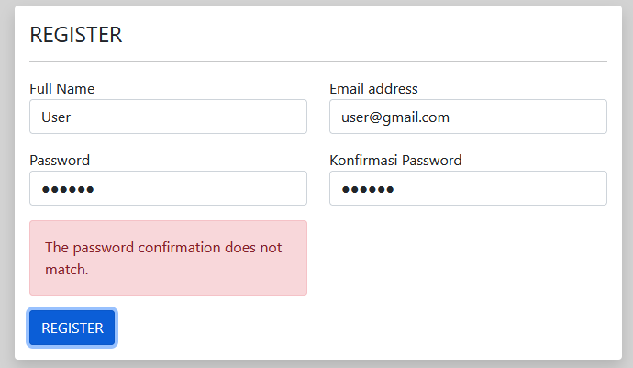

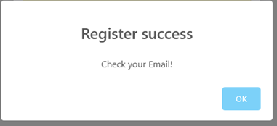

* 1. Reset password (Forgot Password)

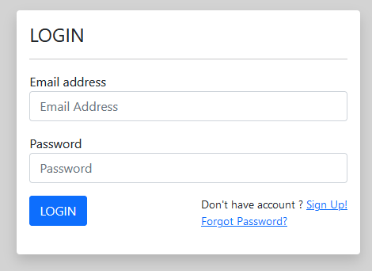

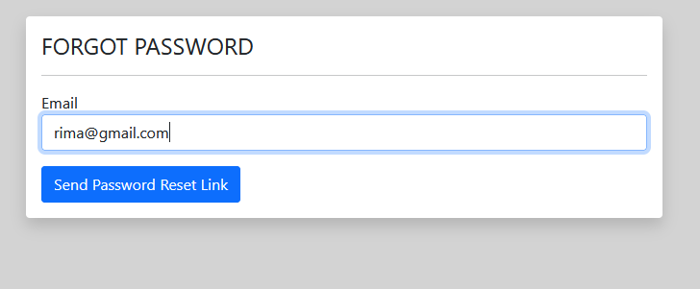

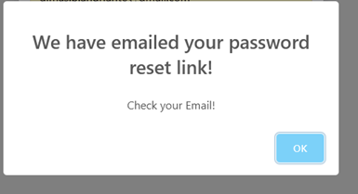

1. Company Feature

In this feature there are 4 featuresthat user can be use, namely:

* 1. Mark Company
  2. Unmark Company
  3. Show List All or Favourite Company
  4. Searching Company by Name

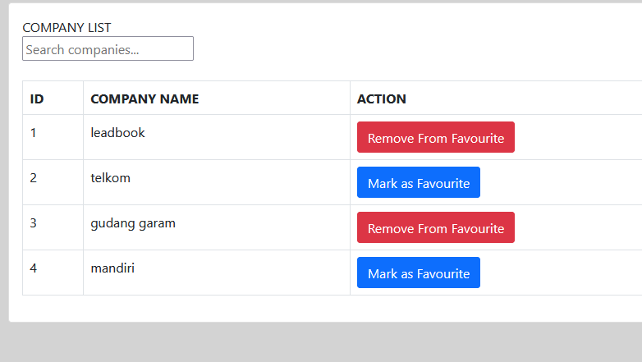

**d**

c

**a**

**b**

# LARAVEL DIRECTORY

Here are the standard directories to make this program and their use:

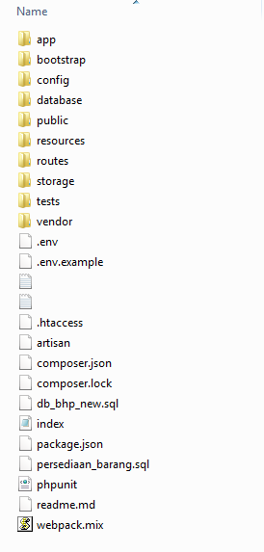

1. app : is the main folder / directory where the application is developed. In this directory there are controllers and models of the application.
2. database : save the migration that we build.
3. routes : The router will examine the HTTP request to determine what the program should do
4. env : set the app configuration

# VUE.js directory

Here are the standard directories to make this program and their use:

1. 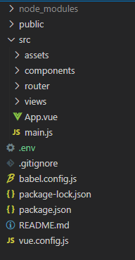src/main.js
2. src/router : to declare the router
3. src/views : to make view and build the process to get and send the data with API
4. .env : set the app configuration
5. Vue.config.js : set the port